

**WORSHIP** – Thursday, Sept. 30 @ 6:30pm and Oct. 3 – 8:00 am and 10:30 am. Please make worship a part of your life.

C:\Users\jemeyer\AppData\Local\Microsoft\Windows\Temporary Internet Files\Content.IE5\YMHTME0W\MC900329305[1].wmf

**MUSIC** –

* Sun., October 10 – Jr. Choir sings at 8:00am service
* Sun., October 17 – 3K, 4K and K sing at 10:30am service

**PRINCIPAL’S PERSPECTIVE-**“Faith in God includes faith in his timing.” I came across this quote and it caused me to pause and think. How often do I ask myself why? It is probably many more times that I should. God has blessed me with so much. He has forgiven my sins and has a place prepared for me in heaven. Asking why is easy for the sinful side of me. The faith that works in me fights that urge to ask why and put my complete trust in God knowing that he has a plan. I may not understand why things are happening the way they are or in the order they are, but God’s timing is perfect. It is my prayer that we all live our faith in God and have faith in His timing.

**SCRIP”S “BONUS FEST”** is coming Oct. 8-31. Each weekend features a different lineup of brands on bonus for 3 days only. Offers will be announced each weekend and all gifts types (eGift cards, physical cards, and money added to reloadable cards) are included. Be on the look out for these great deals heading your way!

[Scrip Bonus Fest](https://shop.shopwithscrip.com/About/WhatsNew/2021/September/30526/bonus-fest)



**PICTURE DAY** is coming up on **Thursday, Oct. 7th**. This year we are encouraging everyone to order pictures online at [Mortensen.orderschoolpix.com](http://mortensen.orderschoolpix.com/) prior to picture day. Find Eastside in the drop down menu, enter password “prepay”, enter your email and submit. We have also included picture packages and pricing in the attached email. Preschoolers who don’t attend on Thursday morning may still come in and have their picture taken.  Preschool pictures will be done right away at 8:00 am with others to follow. Everyone will get their picture taken that day for our school yearbook, even if you don’t order pictures individually. We can’t wait to see all these beautiful smiling faces!

**LAST DAY FOR SHORTS AND CAPRIS** - Our school dress code states that shorts/capris may be worn until the end of September. The weather for Friday still looks to be warm enough for shorts/capris, so **students will be allowed** to wear them on Friday October 1. However, beginning Monday October 4 shorts/capris will not be allowed. Thank you in advance for your cooperation and assistance with this policy.

**PARENT/TEACHER CONFERENCES** – The end of the first quarter is quickly approaching. That means it’s time to sign up for parent/teacher conferences. More information will be coming out next week so keep a look out.

**SCHOOL LIBRARY** - It has been 18 months since the Eastside School Library has been used. That changed this past Monday, September 27. The students, teachers, and librarians are excited to have this opportunity back. A hug thank you to our new librarians, Tori Schwanz and Nellie Bergman.

**In preparing for the use of the library, we noticed there are a number of books missing. We would ask that you please look and see if you have any Eastside Lutheran School library books. If you have a student who graduated in 2020 or 2021 please ask them as well. Thank you!

**OPEN FORUM** -There will be an open forum held on Tuesday November 2 from 7:00-7:30 with the Eastside Lutheran school board and school administration. This will be an opportunity to hear what is happening with the school and get updates on the following: accreditation and the accreditation process; mission, vision, and objectives (MVO); upcoming events. We will leave some time for questions; however, to be able to provide the best and most complete answers possible, questions should be emailed to Mr. Rank ([brank@eastsidelutheran.org](mailto:brank@eastsidelutheran.org)) prior to the forum.

**DO HAVE EXTRA** books? We need new or gently used adult, children’s, teen, cookbooks, hobby books or any other type of book you can think of for the Book Nook area at the craft fair. We are also looking for used puzzles, DVD’s or board games you would be willing to part with. This area of our craft fair is always a big hit and with your help it can be again! Donation bins are located inside the school and church entrances. Thank you for your generosity!

**EASTSIDE LUTHERAN ART & CRAFT FAIR-** As many of you know our Art and Craft Fair is back on this year and quickly approaching! The date is set for Saturday, **November 6, 2021**hereat our school. Some of the areas we will be having at the Art & Craft Fair include craft vendors, gift basket raffle, book nook, cookies by the pound, and bakery items. This event will help raise money towards many items needed here at school and it’s a great time for fellowship between church & school members. It’s also a great way to get people into our facility to see what an awesome school we have.

There are a couple ways you can help out to make this a huge success.

* Sign up to volunteer to help out here:

[Art & Craft Fair 2021](https://www.signupgenius.com/go/5080a4da4a62ea2f94-eastside3)

* Donate items for the Book Nook area (Books: Adult & Children Books, puzzles, CD’s DVD’s , Cookbooks, etc…  (No Toys) Donation bins will be placed out in the lobby area in the next few days.
* Donate a gift basket or donate money to put towards a gift basket   
  [Basket Sign Up for Craft Fair 2021](https://www.signupgenius.com/go/10c0544acad2ba3fd0-20211)
* Please help spread the news about the Craft Fair. Invite your family and friends to come and shop that day.

**CLASSROOM GIFT BASKETS FOR THE RAFFLE-** The Eastside Lutheran Craft Fair Committee is asking each classroom to put together a basket for the gift raffle. The teachers have decided on a theme for each room. Please donate items that fit the theme or your classroom basket or if you would rather donate money for the basket we will do the shopping for you. Donations can be sent to the school with your child or dropped off in the preschool classroom. Please have donations to school by **October 15th.**

Themes for Baskets are:

Preschool- Movie Night Basket

Kindergarten- Cooking with Kids Basket

1st grade- Coffee Lovers Basket

2nd grade- Disney Basket

3rd & 4th grade- Sports Fan Basket

5th grade- Date Night Basket

6th grade- Arts and Craft Basket

7th and 8th grade- Door County Basket (monetary donations accepted for prepurchased basket goodies)

**NEXT CRAFT MEETING** will be held Thursday, Oct.14th at 3:15pm. Please join us!

**EAGLES SPORTS**

**VOLLEYBALL NEWS** – Last Wednesday the 22nd we played Our Redeemer in a home match up. Here are those results.

Also our B team participated in a volleyball tourney in Ixonia on Sunday the 26th and took 3rd place. Way to go Eagles!

Here are those results:

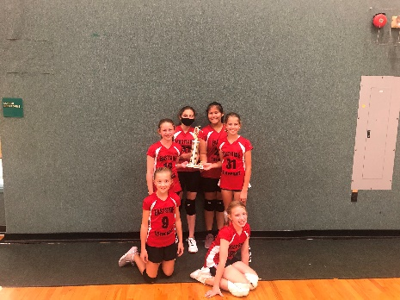Game 1 Game 2

Eastside vs. Peace Eastside vs. Stephens

15-9 W 15-3 W

13-15 L 16-17 L

Game 3 Game 4

Eastside vs. TSL Eastside vs. Crown of Life

15-5 W 12-15 L / 15-10W

15-6 W 15-8 W

Game 5 Game 6 for 3rd place

Eastside vs Peace Eastside vs St. Marks, Oconomowoc

10-15 L 16-14W

6-15 L 15-8 W

We are looking forward to our final HOME game tonight vs Peace. Come on out and cheer us on at 4 & 5pm! As always concessions are available!

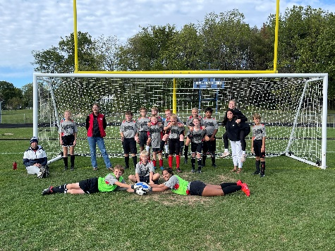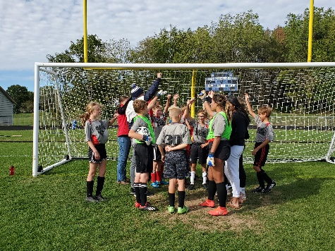

**SOCCER NEWS** –We finished up our session this past weekend at the BLAC Conference meet. We tied our first match at 0’s against Columbus. Our second match was against Juneau and we lost 3-1 but finished the meet with a win against Oconomowoc at 4-2. We came a long way as a team and a lot of good memories were made. Thank you to Coach Wilson and Coach Morgan for another great year!

**CROSS COUNTRY NEWS** – We have been running like crazy! Eastside snuck in two meets this past week. We participated in a meet in Sun Prairie on Thursday the 23rd. Then we ran Monday the 27th in a meet at Lakeside Lutheran High School. We love running so this was a pretty great week!

Happy Birthday!

October 1 – Rudved Krishna – PreK

October 1 – Wilhelm Schwark – 6th grade

October 1 – Keith Stiemke – 1st grade

October 2 – Zion Fleming – 4th grade

October 4 – Mr. Rank

Eagle Events

 Volleyball Cross Country

Sept. 29 - HOME vs Peace Oct. 9 – State Meet (optional)

Oct. 2 – A team tourney @ Prep 11 – BLAC meet @ TBS

Oct. 6 – AWAY @ St. John’s, Juneau

Oct. 16 – A tourney @ LLHS

Music

Oct. 10 – Jr. Choir @ 8:00 service

Oct. 17 – PreK& K

Other

Oct 7 – Picture Day

Oct. 15 – Power Hour – 9-10:30am

Oct. 15 – End of First Quarter

Oct. 20-21 - Parent/Teacher Conferences

Oct. 22 – NO SCHOOL

Oct. 28-29 – NO SCHOOL

